Compare Index Performance Against Benchmark
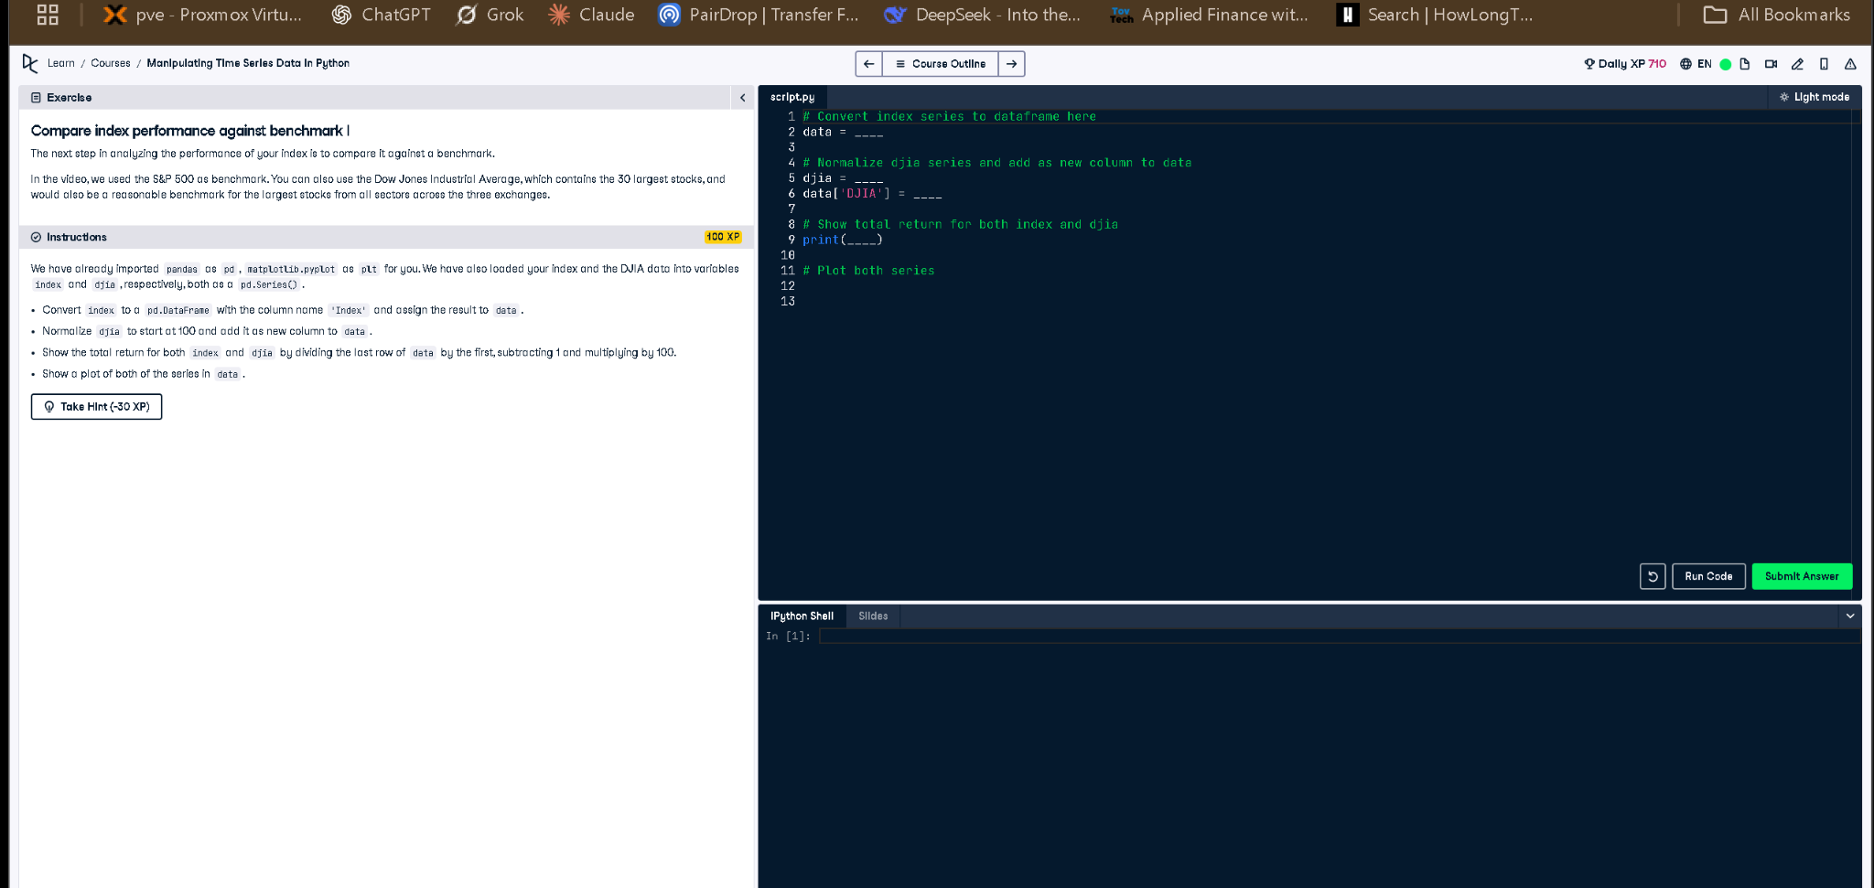
Figure: Screenshot of the exercise and code editor

Correct Python Code
# Convert index series to dataframe here
data = index.to_frame(name='Index')
# Normalize djia series and add as new column to data
djia = djia / djia.iloc[0] * 100
data['DJIA'] = djia
# Show total return for both index and djia
print((data.iloc[-1] / data.iloc[0] - 1) * 100)
# Plot both series
data.plot(title='Index vs DJIA')

Explanation
This task compares your custom index to the DJIA benchmark. First, it converts the index into a DataFrame. Then it normalizes DJIA to start at 100 for comparison. The total return of both is calculated by comparing the last and first values. Finally, both are plotted to visualize performance.

